# **Segmenting Annapolis, Maryland Neighborhoods**

# Garret B. Grimes

# IBM Data Science Capstone

April 20, 2021

**Introduction to Business Problem**

The purpose of this assignment is to devise a problem statement and then discuss what data will need to be retrieved as well as the methodology for cleaning that data and visualizing it in a way that can answer the problem statement. The problem statement we will be discussing is where to open a new bar establishment in the Annapolis, Maryland area. We already know that there is a saturation of bars in the downtown Annapolis area. The individual that is wanting to open a bar knows this and had already tried to explore that option, however the real estate prices in that area is very high so they are looking for other options within the Annapolis area. They do plan to open a chain of bars later, however, since this individual is “all in” on making this happen and doesn’t have a plethora of capital, they have to be very careful in the selection of the area that they choose to open their first bar.

**Methodology**

The first thing we will need to retrieve is all of the neighborhoods (or towns) in the Annapolis, Maryland area. For this, we will use Wikipedia and we will use beautiful soup to help us scrape the html data from the webpage. After that, we will retrieve the geographical coordinates utilizing the Geocoder package. Next, we will utilize the FourSquare API to get the top venues. We will then set up the One Hot encoding in order to analyze each neighborhood and the venues. After that we will need to write a loop to look at the frequency of the categories. Finally, we will utilize k-means clustering in order to cluster the data to the nearest centroid in order to see what neighborhoods have the highest saturation of bars.

**Results**

The results that we found is that the Cluster labels of 1 have the highest concentration of bars which is the areas closest to the downtown areas of Annapolis. Clusters 0, 2, 3, 4 did not have any bars in the 10 most common venues.

**Discussion**

As noted in the results, the vast majority of the bars are closest to the downtown area of Annapolis which was Cluster label 1. Clusters 2 and 0 both have Gastropubs which are pubs that sell high quality food which could be good for the first bar location. Cluster 4 has nothing alcohol related in the top 10 venues which could point to a discussion of whether or not a bar would survive in this area.

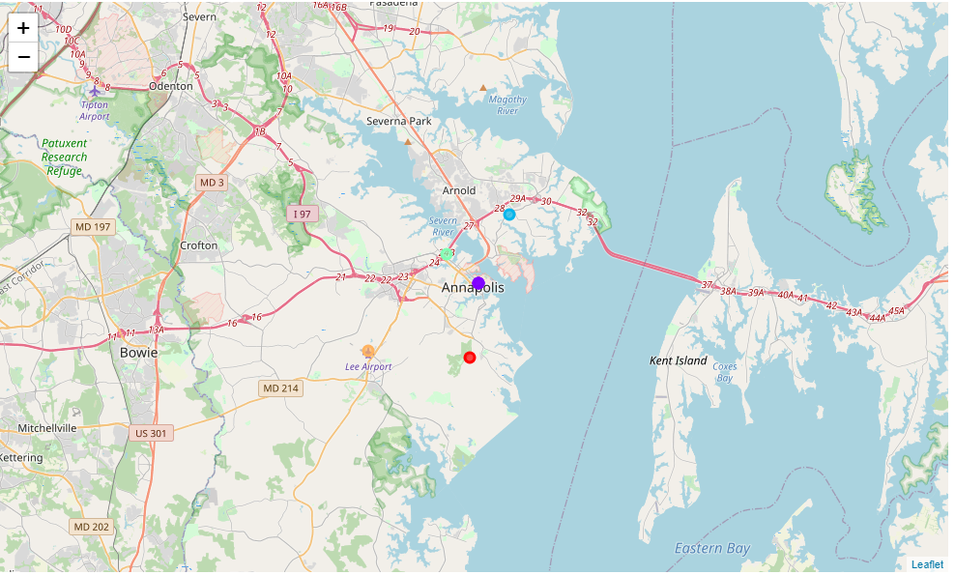

**Conclusion**

We recommend that the individual open a bar in Parole, Maryland. The reason behind this recommendation is that they have liquor stores as the 3rd most common venue and gastropubs as the 7th most common venue. This proves that the market is there and that individuals living in this area would likely patron a new bar establishment since there are not many there.

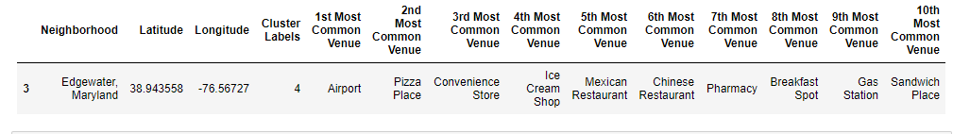

**Outline of Portfolio**

As for the outline of my e-Portfolio, I believe I will start it with my personal branding statement. After that, I will likely go into a more in-depth summary of who I am and include some pictures of some of my past experiences in order to better portray my personal branding statement and get a glimpse of what I enjoy. In the next section I will include some of the goals that I have attained as well as some of my future goals. I will also include the learning objectives that I have mastered here at American Military University and provide proof of the mastery in the form of the artifacts that I have previously talked about in previous assignments in this course. I will also include some graphics in this section in order to further attract the reader in order to make the section more impactful. I think I will also include the courses that I have taken that I believe are the most relevant to my career goals so potential employers can see specifically what learning I have attained over my time at the university. In the next section, I will highlight my time in the Air Force and provide some links to projects I have been a part of so employers can see some of the programs that I have created. I will also provide a list of jobs I have held in the Air Force as well as the scope of responsibility I have so they will be able to see that I have been leading teams for the past 15 years. I think it might be beneficial to also list some awards that I have earned while being in the military to show that I have been a strong performer and am very results oriented. I will describe the outline in bullet format below:

* Welcome
  + Personal Branding Statement
  + About Me (will include some pictures)
* Goals
  + Goals that I have attained
  + Long term goals
* University Learning Objectives
  + List them out (Upload artifact proofs)
  + Include relevant coursework
* Work Experience
  + Jobs held (include scope of responsibility)
  + Projects (include some screenshots for a visual)
  + Awards (include some pictures)

**Conclusion**

I think that my personal branding statement shows that I really enjoy looking at issues and helping organizations come up with problem statements. It shows that I can analyze issues effectively and come up with innovative solutions in order to increase effectiveness. Additionally, I have discussed how I want to structure my e-Portfolio so that it catches the attention of the reader and is well organized so employers can see that I have mastered my learning objectives and they can get a clearer picture of who I am and what value I can bring to an organization.